Restaurants
Name
Institution
Date

Restaurants
My topic of interest is restaurants. A restaurant is a place where food and drinks are prepared and served to customers. It is an interesting topic since the restaurant industry has continued to evolve over the years and many people get their meals in restaurants. While most meals are prepared and consumed on the premises, many restaurants now have take-out and grocery delivery services.
Restaurants have long been an important part of a vibrant society's business, physical, intellectual, and creative life. Considering the cafes of Paris in the 1920s, the three-martini lunches of the 1950s and 1960s, restaurants have evolved very much, and there is room for change in the industry (Feldman, 2015). Restaurants are where significant life events, both personal and professional, are commemorated. Around a restaurant table, strangers become friends and occasionally become lovers around a restaurant.
Restaurants are more important now than they have ever been. Restaurants are now at the core of American life in the twenty-first century. In the near future, millions of Americans will prefer to get their meal in restaurants instead of waiting at tables, preparing meals, and washing dishes. Restaurants have traditionally satisfied a human desire for interaction and formed social ties, in addition to their essential function of providing food and drink. Restaurants are playing an enormously significant role in influencing our overall economy as well as the essence and makeup of our cities in the twenty-first century.
In a digitized and globalized world, restaurants play a larger role in our economy and job creation. Many restaurants are able to achieve and maintain the same productivity with far fewer workers. Due to globalization, jobs are often produced far from where goods or services are produced.
Restaurants are the last shining beacon of commercial industry, and they provide a large number of jobs as a result. The sector actually hires around 10% of the United States' total population. According to the National Restaurant Association, the industry will have employed around 15 million people by 2024 (Feldman, 2015). Like any other industry, restaurants can help with economic stability and mobility issues. Jobs in the sector are available to people from all walks of life. The barriers to entry in terms of qualification and schooling are minimal compared to other industries.
The restaurant industry revolves around the following trends;
- Digitization
- Globalization
- Urbanization
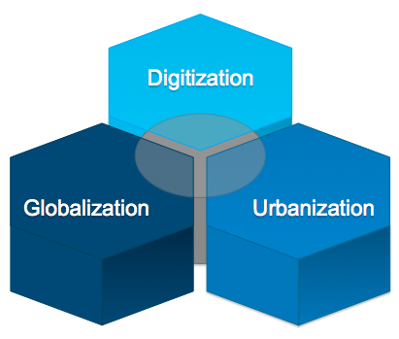
Types of restaurants
There are different types of restaurant but the main ones are;
- Fine Dining.
- Casual or Family-Style.
- Cruise Line.
- Food Hall.
- Food Truck.


The restaurants provide four types of foodservice systems which are:
- Conventional.
- Commissary.
- Ready prepared.
- Assembly or serve

Contact information
Contacts by Food Preference
List Name Contacts Date created
Vegetarians 7 Jan 16, 2021
Kids Menu 12 Dec 6, 2020
Holiday Menu 30 Dec 15, 2020

The topic of a restaurant is important for everyone and the economy. Therefore, it is time to start talking more about how important the restaurant industry is to our economy and culture (Thompson, 2017). Not only talk about the industry, but necessary measures also need to be put in place to encounter the challenges facing restaurants' investments. There are real and complicated issues that must be resolved and overcome in order for the industry to successfully bear the weight that will be expected in the coming decades.
Link to the topic
https://medium.com/@EliFeldman/why-the-restaurant-industry-is-the-most-important-industry-in-todays-america-6a819f8f0ac9
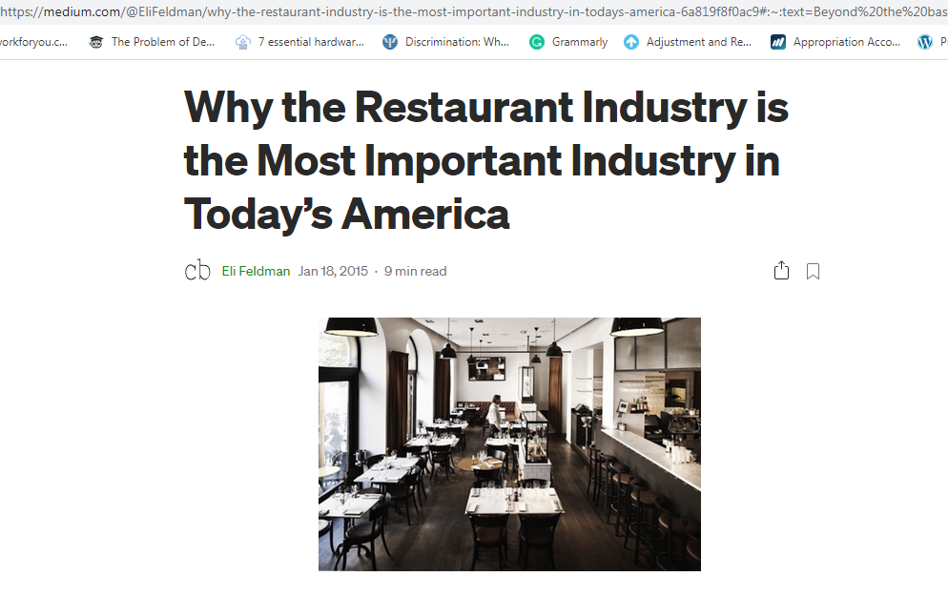

References
Feldman, E. (2015). Why the Restaurant Industry Is the Most Important Industry in Today’s America. Medium, January, 18. Retrieved from: https://medium.com/@EliFeldman/why-the-restaurant-industry-is-the-most-important-industry-in-todays-america-6a819f8f0ac9
Thompson, D. (2017). The Paradox of American Restaurants. Atlantic.

